Chapter 5 notes

**What is algorithm:**

It’s a clearly specified instructions the computer will follow to solve a problem

Want to know which way is faster.

With a method to do more if you pass it a bigger number than it takes longer

1000 runs at 684658

2000 runs at 264249

We expected it to run longer because we gave it 2x as much but the second time ran faster

This is a guess

Since it is in the jvm has already loaded the information it is faster the second time

When trying to figure the times we are using the mean but some outliers throw us off so then we use the medium to see if it could improve

If you can run in N log N that is the goal that we want to go for

If you have some bad input then some will be better. Like quadratic or cubic

Linear is usually always the fastest

**Moderate inputs**: linear is faster, log n log next, then quadric, then cubic

Constant will be better then linear

How much better will be better

Cubic was the worst so 10 N^3 + N^2 + N

Log represents a function whose dominant term is N. (N log )

**Big-Oh** notation is the term used when we only discuss the dominants term

|  |  |
| --- | --- |
| C | Constant |
| Log N | Logarithmic |
| Log^2N | Log-Squared |
| N | Linear |
| N Log N | N Log N |
| N^2 | Quadratic |
| N^3 | Cubic |
| 2^N | Exponential |

Theorem 5.1 red ball is lower then number and blue is more the highest

1<=I<=k<=j

Example: pull out red, 4, 8

Get 4, 4, 8

5.4 HW

X^2, x maybe more

* + 5.23 - Let's define 'larger' to mean 'has more employees.'  Further note: When a company swallows up Joe's company, they don't fire anyone, they keep all the employees, including Joe.  For example, if Joe works in a company of 10 employees and that company gets swallowed up by a second company with 11 employees, the resulting company will have 10+11 = 21 employees.

**Unlucky Joe** Joe works for a company with n employs. Joe company always gets bought out by a company with more employs. So how many companies has he been bought by.

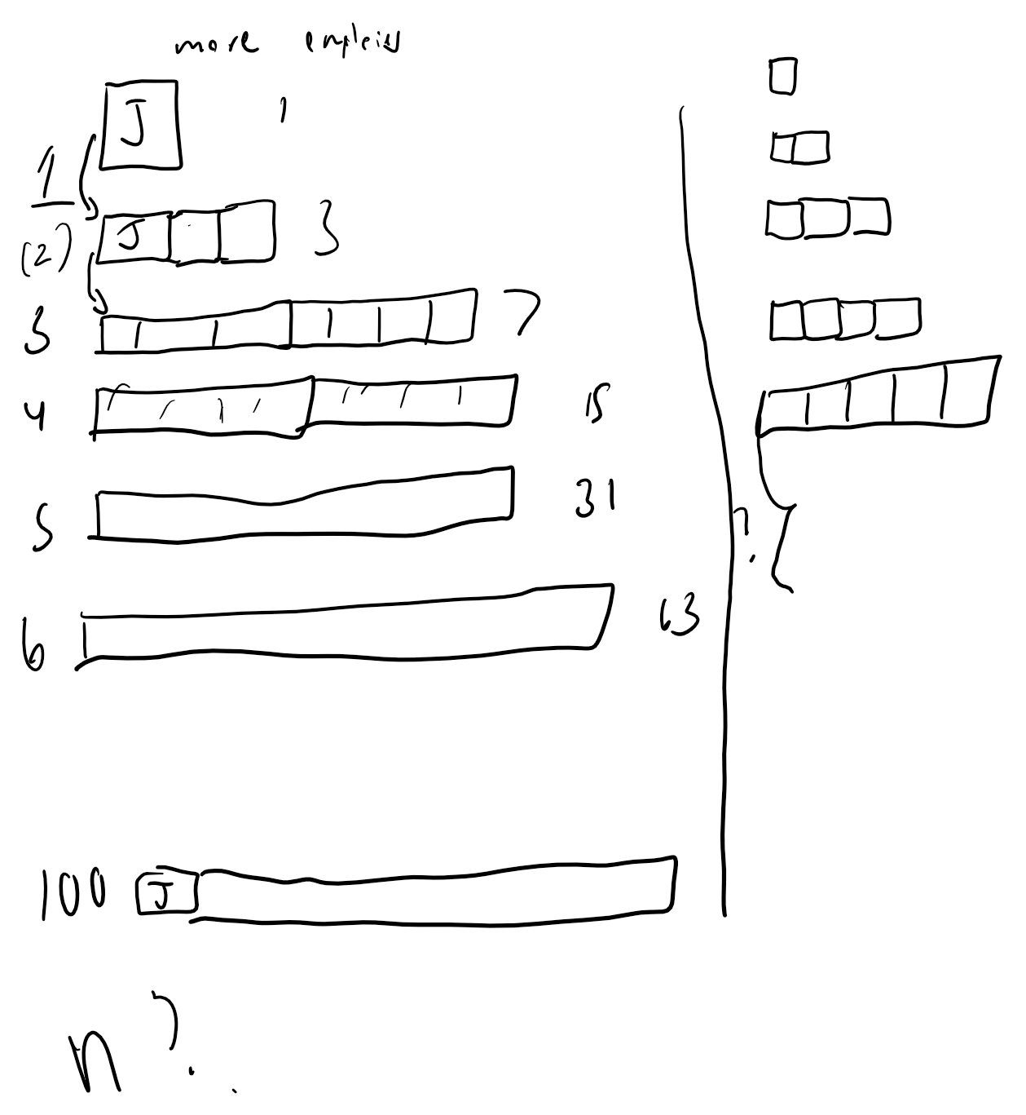

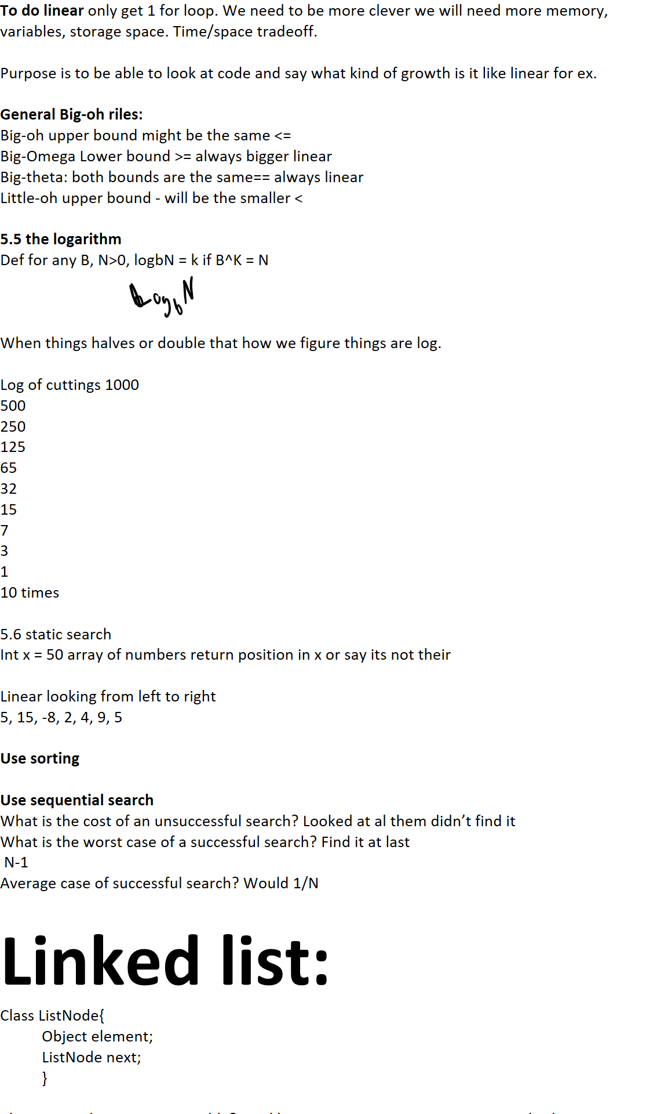  
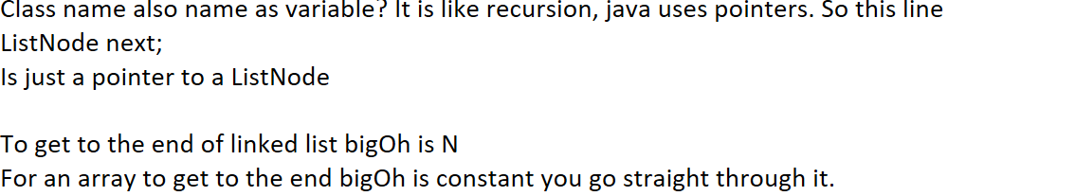

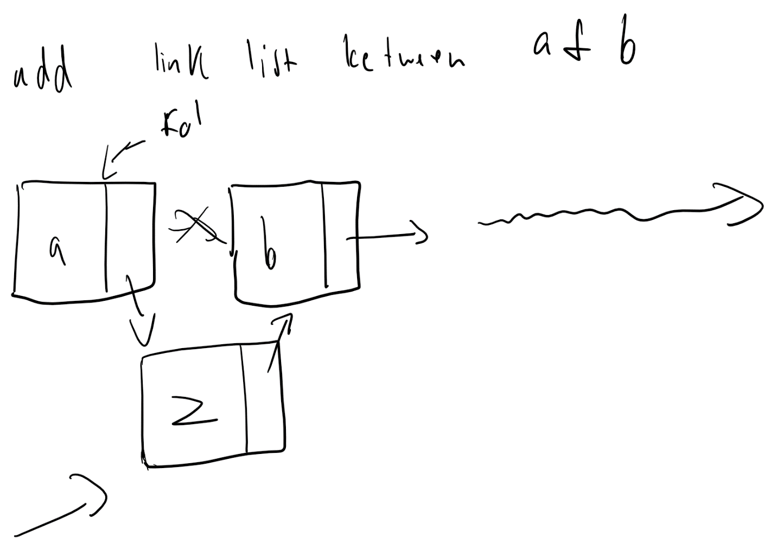

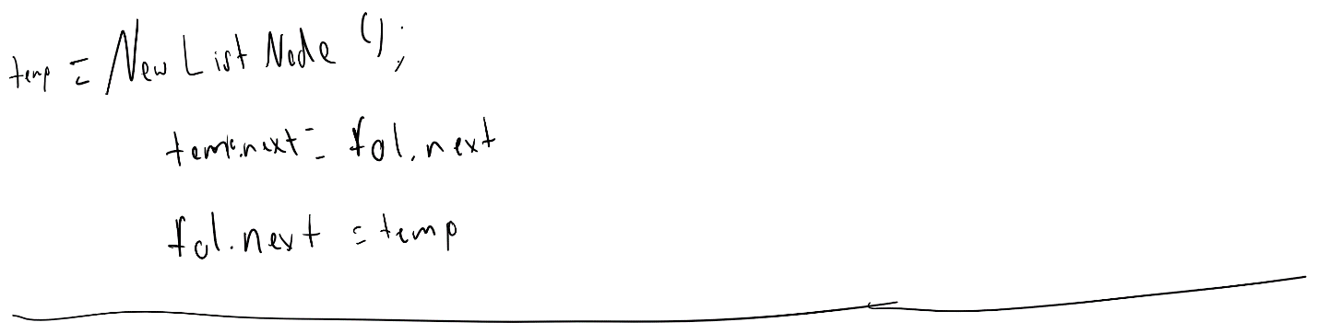

Constant BigOh if you are putting stuff at the front for link list

Array for adding to the front would be BigOh N

Where would you want to use array or link list

Keep track of people by there height.

New person average middle height would matter which one you picked

If you have a group and you know the tallest person comes in first and everyone else is after you want to add shortest in first slot. Best would be link list because you know you can add to the front rather then array.